**Person Detection output**

We used two models here:

1. Custom Model
2. Pre-trained Model

Output of custom model:

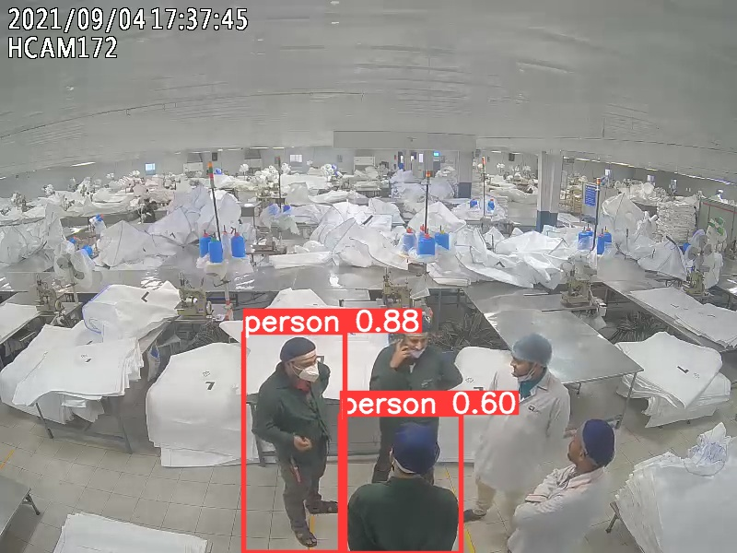

Custom model output

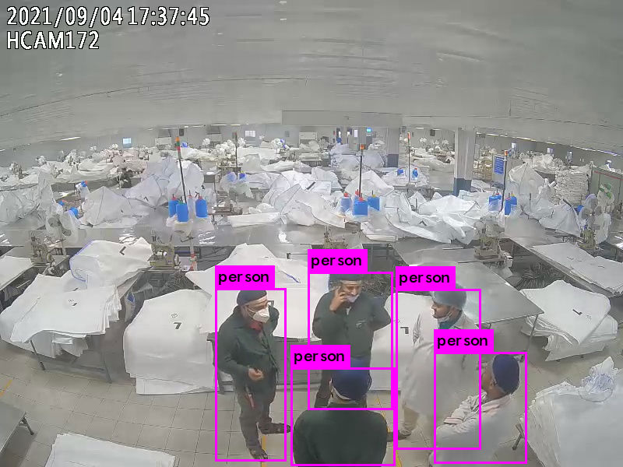

Pre-trained Model Output

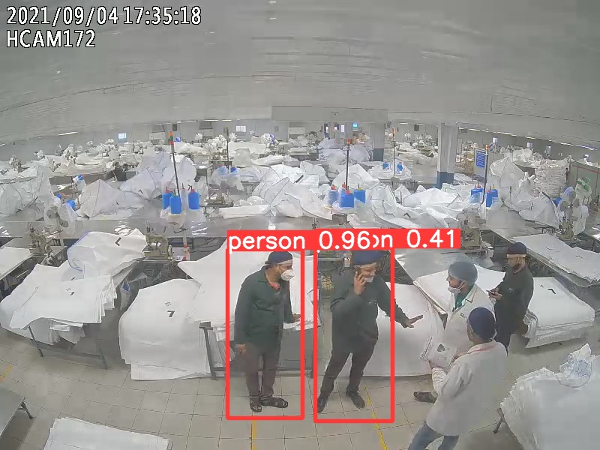

Custom model output

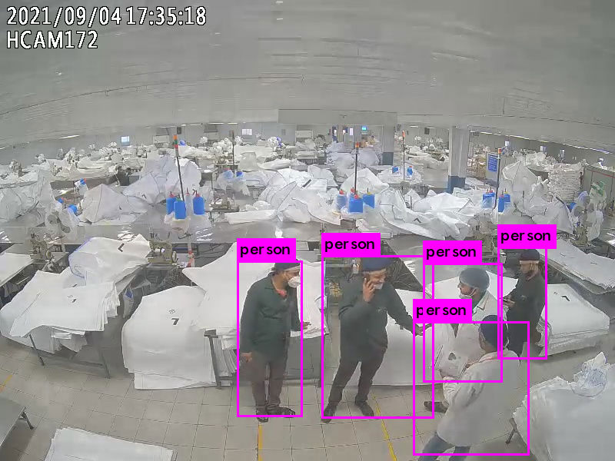

Pre-trained Model Output

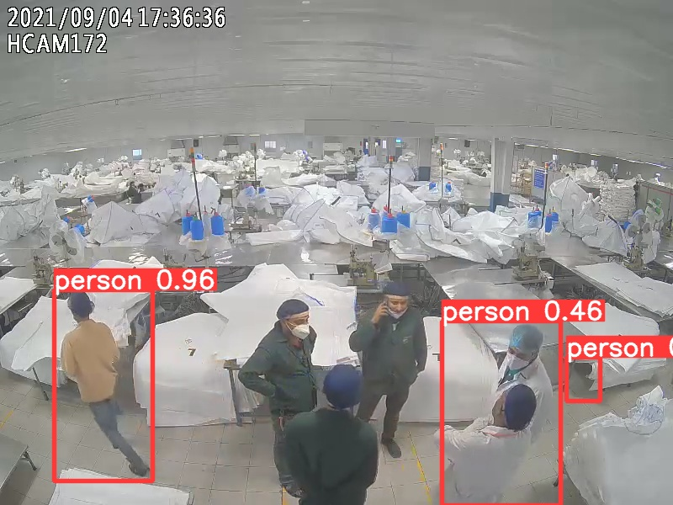

Custom model output

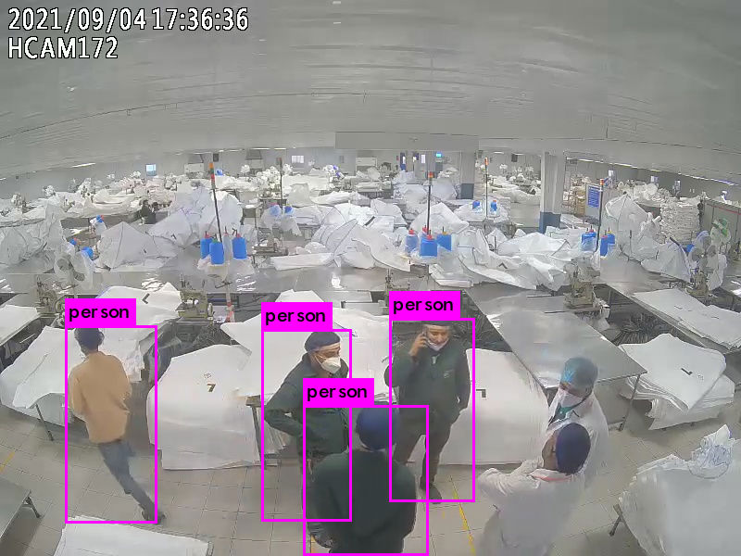

Pre-trained Model Output

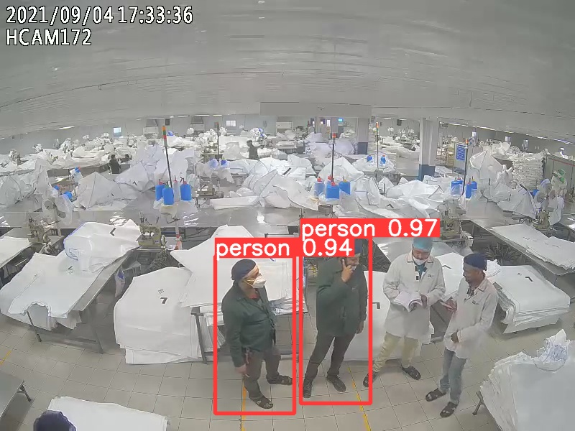

Custom model output

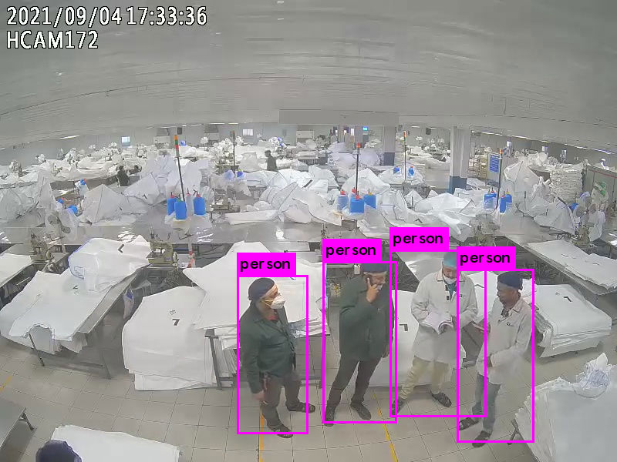

Pre-trained Model Output

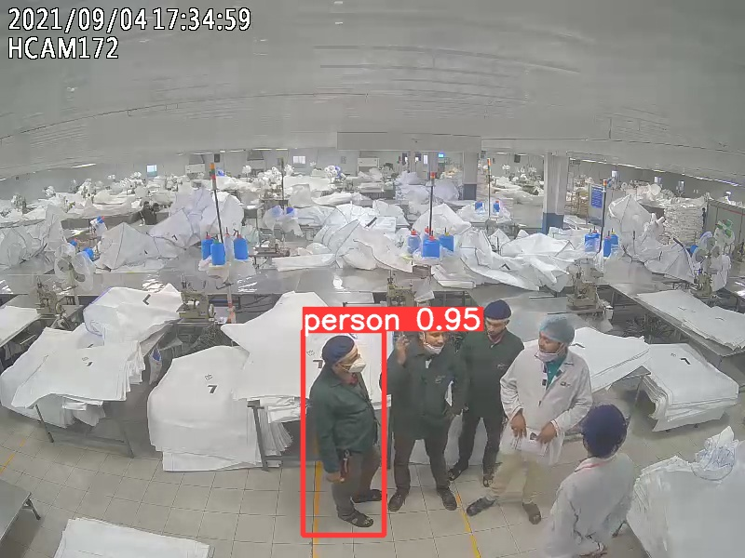

Custom model output

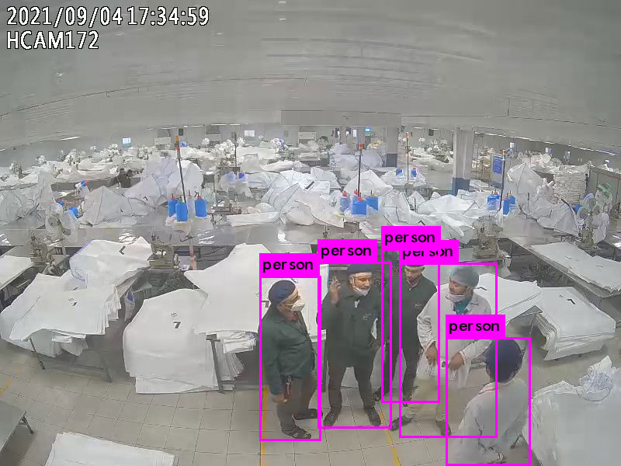

Pre-trained Model Output

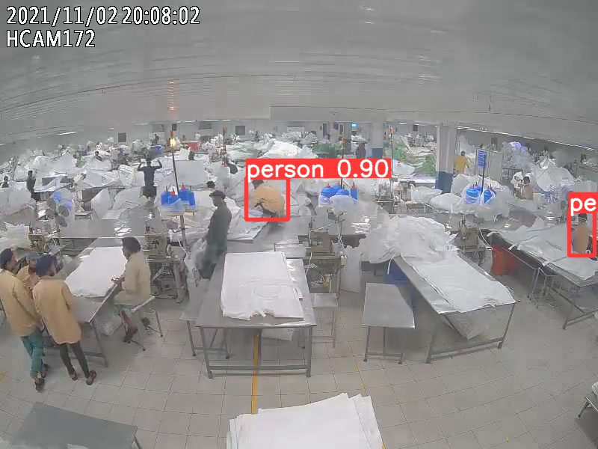

Custom model output

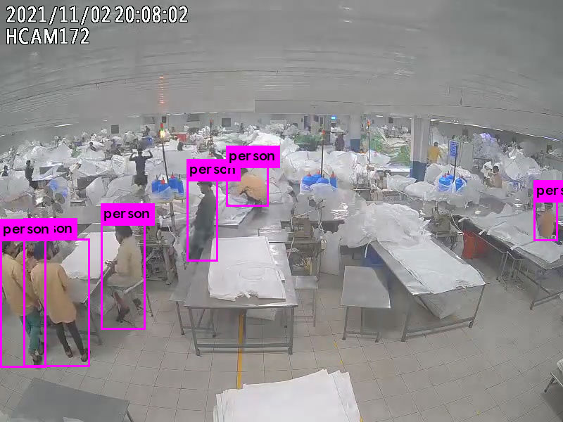

Pre-trained Model Output

“Custom model is not performing well and not detecting all the person in the frame.”

“In comparison of these two models Pre-trained model is performing well and detecting well number of person in the frame.”